BOREAS HYD-01 Volumetric Soil Moisture Data

Summary

The BOREAS HYD-01 team made measurements of volumetric soil moisture at the SSA and NSA tower flux sites in 1994 and at selected tower flux sites in 1995-97. Different methods were used to collect these measurements, including neutron probe and manual and automated TDR. In 1994, the measurements were made every other day at the NSA-OJP, NSA-YJP, NSA-OBS, NSA-Fen, SSA-OJP, SSA-YJP, SSA-Fen, SSA-YA, and SSA-OBS sites. In 1995-97, when automated equipment was deployed at NSA-OJP, NSA-YJP, NSA-OBS, SSA-OBS, and SSA-OA, the measurements were made as often as every hour.

Table of Contents

* 1 Data Set Overview
* 2 Investigator(s)
* 3 Theory of Measurements
* 4 Equipment
* 5 Data Acquisition Methods
* 6 Observations
* 7 Data Description
* 8 Data Organization
* 9 Data Manipulations
* 10 Errors
* 11 Notes
* 12 Application of the Data Set
* 13 Future Modifications and Plans
* 14 Software
* 15 Data Access
* 16 Output Products and Availability
* 17 References
* 18 Glossary of Terms
* 19 List of Acronyms
* 20 Document Information

1. Data Set Overview

1.1 Data Set Identification

BOREAS HYD-01 Volumetric Soil Moisture Data

1.2 Data Set Introduction

The Hydrology (HYD)-01 team made measurements of volumetric soil moisture at the BOReal Ecosystem-Atmosphere Study (BOREAS) Southern Study Area (SSA) and Northern Study Area (NSA) Tower Flux (TF) sites in 1994 and at selected TF sites in 1995-97. Different methods were used to collect these measurements, including neutron probe, and manual and automated Time Domain Reflectometry (TDR). In 1994, the measurements were made every other day at the NSA-Old Jack Pine (OJP), NSA-Young Jack Pine (YJP), NSA-Old Black Spruce (OBS), NSA-Fen, SSA-OJP, SSA-YJP, SSA-Fen, SSA-Young Aspen (YA), and SSA-OBS sites. In 1995-97, when automated equipment was deployed at NSA-OJP, NSA-YJP, NSA-OBS, SSA-OBS, and SSA-Old Aspen (OA), the measurements were made as often as every hour.

1.3 Objective/Purpose

The objective of collecting these volumetric soil moisture profiles was to better understand the hydrological processes of the boreal forest.

1.4 Summary of Parameters

Volumetric soil moisture is defined as the unit volume of water per unit volume of soil.

1.5 Discussion

The HYD-01 team has worked on the calibration of the United States Department of Agriculture (USDA) Salinity Lab HYDRUS finite element model of soil water movement for the BOREAS tower sites. Initial calibration of this physics-based model has been made to the tension infiltrometer data (BOREAS HYD-01 Soil Hydraulic Properties) collected at each site. The next step will be calibration of the model root sink function (Feddes et al., 1978) using the soil water transect data collected during the 1994 Intensive Field Campaigns (IFC) and the time series collected at NSA-OBS site beginning in mid-July 1995 using automated TDR. Model verification will be made using soil moisture data collected during the 1996 field operations. The calibrated model will be coupled to data from the BOREAS Information System (BORIS) detailing soil texture and plant canopy distribution and density at each tower site. Soil water content profiles and soil hydraulic properties were measured at the flux tower sites as described in Cuenca et al., 1997. The mean zero-flux depth between measurement periods was used to separate evapotranspiration (ET) from drainage. A semiautomated procedure was developed to locate the zero-flux depth by first transforming the measured soil water content profiles to absolute total head profiles using the soil hydraulic properties determined at each site (Cuenca et al., 1997). The direction of water flow was resolved from the slope of the total head along the profile, and the zero-flux plane separating drainage from ET was located. ET and drainage were calculated from the soil water content profiles as changes in soil water stored in the profile above (ET) and below (drainage) the mean zero-flux depth. Cumulative ET and drainage were calculated from the mean of five measured soil water content profiles to a depth of 165 cm spaced approximately 5 meters apart along a transect in the vicinity of the tower site. Water flux was measured independently at the tower top (30 m) using the eddy correlation technique (Moore and Fitzjarrald, preliminary flux data set, BORIS 1996) and compared to the soil based measurements.

1.6 Related Data Sets

BOREAS HYD-01 Under Canopy Precipitation Data
BOREAS HYD-01 Soil Hydraulic Properties
BOREAS HYD-06 Moss/Humus Moisture Data
BOREAS HYD-06 Ground Measurements of Soil Moisture
BOREAS HYD-06 Aircraft Gamma Ray Soil Moisture Data

2. Investigator(s)

2.1 Investigator(s) Name and Title

Dr. Richard H. Cuenca
Professor
Oregon State University

2.2 Title of Investigation

Coupled Atmosphere-Forest Canopy-Soil Profile Monitoring and Simulation

2.3 Contact Information

For information regarding 1994 data collection:

Contact 1
---------
David Stangel
Oregon State University
Corvallis, OR
(541) 737-6314
(541) 737-2082 (fax)
stangel@pandora.bre.orst.edu

For information regarding 1995 to 1997 data collection:

Contact 2
---------
Shaun Kelly
Oregon State University
Corvallis, OR
(541)-737-6314
(541) 737-2082 (fax)
kellys@pandora.bre.orst.edu

For general inquiries:

Contact 3
---------
Dr. Richard Cuenca
Professor
Oregon State University
Corvalis, OR
(541) 737-6307
(541) 737-2082 (fax)
cuenca@engr.orst.edu

Contact 4
---------
David Knapp
Raytheon ITSS
NASA GSFC
Greenbelt, MD
(301) 286-1424
(301) 286-0239 (fax)
David.Knapp@gsfc.nasa.gov

3. Theory of Measurements

Neutron Probe

The neutron probe is used to measure volumetric water content of soils. It is lowered into an aluminum access tube (1.5-in. diameter), and the neutron source emits “fast” neutrons into the soil profile while undergoing radioactive decay. The “fast” neutrons collide with similar sized hydrogen atoms found in water molecules. These collisions yield “slow” neutrons due to the conservation of momentum. A detector mounted near the neutron source counts the “slow” neutrons reflected from the hydrogen collisions. The detector count is proportional to the number of water molecules present in the effective radius of influence of the probe, providing a proportional measure of soil moisture. The detector count is converted to volumetric soil water content using a linear regression equation whose coefficients are determined through regression of neutron probe counts to soil sample measurements.

MoisturePoint TDR

The process of sending electric pulses down a coax or wave-guide and observing the reflected pulses is called TDR. It is popularly used to determine the location of failures in telecommunications cables. A waveform traveling down a coax or wave-guide is influenced by the dielectric properties of the material surrounding the conductors. The dielectric properties of a material can be characterized by its dielectric constant. The dielectric constant of a medium is the ratio of the velocity with which an electromagnetic pulse will travel along a wave-guide in the medium to the speed through a vacuum (speed of light). A pulse propagating along a wave-guide surrounded by air is characterized by a dielectric constant of 1, while the same wave-guide surrounded by water will propagate approximately 78-80 times slower because the dielectric constant of water is much higher (78-80). Because the dielectric constant of water is so much higher than that of most materials, a signal within a wet or moist medium propagates slower than in the same medium when dry. The dielectric constant of dry soil is approximately 4-5. Bulk soil ionic conductivity affects the amplitude of the signal but not the propagation time. The soil volumetric water content can thus be determined by measuring the propagation time over a fixed length probe embedded in the medium being measured.

The simplest soil probe consists of two parallel rods inserted into the soil. A reflectometer is used to measure the travel time of a series of pulses sent down the wave-guide surrounded by the soil. The reflectometer used in our research is the MoisturePoint MP-917 TDR. MoisturePoint uses TDR as its baseline technology, but also employs novel signal discrimination and processing techniques to solve the signal-to-noise ratio, waveform detection and discrimination, signal quality validation, and circuit stability problems specific to soil applications of TDR. Probably the most unique feature of the MoisturePoint system is the segmented probes that allow one to obtain a soil water profile from a single probe, with minimal disturbance of the surrounding soil. The probes are constructed of stainless steel epoxy and high-density plastic. The probe looks like a short black spear with stainless steel sides and a rectangular cross section approximately 1 cm by 2 cm. The spatial segments are defined by electronic components encapsulated at intervals within the probe. The MP-917 interrogates a probe and reduces the segment data to a numerical probe data set for display or for export to a data-logger. It takes about 90 seconds for the instrument to interrogate, analyze data, and log the standard five segment probes used in this study.

Automated TDR

Two types of automated TDR systems were operated in 1995-97. The first type was a set of eight MoisturePoint five-segment probes multiplexed to one MP-917 reflectometer. The theory of operation was identical to that of the MoisturePoint TDR used for manual measurements described in the previous section. This system used a Campbell Scientific, Inc., CR10 data-logger to control external multiplexing switches and record the data. This system operated by sequentially measuring eight five-segment probes switched individually to the MP-917 under control of a program stored in the CR10.

The second type of automated TDR system used a CR10X data-logger to measure and log the output from the Campbell Scientific, Inc., Model CS615 Water Content Reflectometer. The CS615 provides a measure of the volumetric water content of porous media using time domain measurement methods. The water content is derived from the effect of a changing dielectric constant on the propagation velocity of electromagnetic waves along a wave-guide. The CS615 consists of two stainless steel rods connected to a printed circuit board potted in an epoxy block. A five-conductor cable is connected to the circuit board to supply power, enable the probe, and monitor the pulse output. High-speed electronic components on the circuit board are configured as a bistable multivibrator. The output of the multivibrator is connected to the probe rods that act as a wave-guide. When the multivibrator switches states, the transition travels the length of the rods and is reflected by the rod ends. This reflection provides feedback to switch the state of the multivibrator. The travel time to the end of the rods and back is dependent on the dielectric constant of the material surrounding the rods. The dielectric constant is predominantly dependent on the water content. Digital circuitry scales the multivibrator output to an appropriate frequency for measurement with a data-logger. The CS615 output is essentially a square wave with an amplitude wing of +/-2.5 volts of direct current (VDC). The frequency of period of the square wave is used for the calibration of water content.

The dielectric constant of the soil is a weighted summation of the dielectric constants of the soil constituents (air, water, mineral). Since the dielectric constant of water is significantly higher than other constituents, changes in soil water content have a large effect on the bulk dielectric constant of the soil. The frequency of period output signal of the CS615 is related to the volumetric water content through an empirically derived third degree polynomial typical of most mineral soils. The intrinsic dielectric constant of soils in the dry state varies because of different parent materials and bulk density. The calibration equation for soils with significantly different intrinsic dielectric constants will appear as an offset. The calibration equation is then optimized for each particular soil through the last term in the third degree polynomial (zero order term) to compensate.

4. Equipment

4.1 Sensor/Instrument Description

Neutron Probe

The neutron depth moisture gauge is a portable instrument that measures the subsurface moisture in soil and other materials by use of a probe containing a source of high-energy neutrons and a slow (thermal) neutron detector. The probe is lowered into a predrilled and cased hole of 1.5-inch diameter aluminum irrigation pipe. Hydrogen as present in the water in the soil slows the neutrons down for detection. The moisture data are displayed directly in units of interest on an above-surface electronics assembly that is integral to the source shield assembly.

MoisturePoint TDR

The MoisturePoint system is a portable instrument approximately 12 x 12 inches that connects by cable to the top of the 1.2-meter segmented TDR rods previously installed into the soil at the measurement locations.

Automated TDR

The automated MoisturePoint system consists of eight 1.2 meter five-segment TDR rods installed along a transect wired to the MP917 TDR meter through a series of multiplexing switches controlled by a CR10, datalogger. The instruments (MP917, CR10, and multiplexors) are housed in a weatherproof black plastic case (27 x 19 x 10 in.) located at the center of the transect. Coax signal cable and five-wire multiconductor cable from the individual probes are placed on top of the ground and enter the plastic case through a waterproofed entrance. The black plastic case and battery are housed in a wooden box constructed to prevent damage from the occasional bears that occasionally frequent the area.

The automated Campbell CS615 system consists of a set of eight probes installed as two separate profiles of four depths one on top of the other. The probes are inserted parallel to the ground surface, and cables emerge from the ground together and run over the ground to the CR10X datalogger. The CR10X datalogger is housed in a 12 x 18 x 10 weatherproof enclosure outside. The system is powered by an external 12-V deep cycle battery using a 120-V automatic battery charger (1995) or solar panel (1996-97).

4.1.1 Collection Environment

These data were collected at various forested sites in the BOREAS NSA and SSA under a range of ambient environmental conditions.

4.1.2 Source/Platform

The equipment was transported in the field by hand. The neutron probe, when measuring, rested on top of the aluminum access tube that protruded from the soil surface approximately 20 cm. The MoisturePoint system could be placed anywhere on the ground within cable length (2 m) of the top of the TDR rod being interrogated.

4.1.3 Source/Platform Mission Objectives

Not applicable.

4.1.4 Key Variables

Volumetric Soil Moisture

4.1.5 Principles of Operation

These systems were used to determine volumetric soil moisture by measuring a surrogate phenomenon that is related to volumetric soil moisture.

Neutron Probe: The number of returning slow neutrons is measured, which can be converted to moisture content using calibration.

MoisturePoint Manual TDR: The time it takes the generated electric field to propagate along the length of TDR segment being interrogated is measured. This time is then converted to moisture content using an internal calibration within the MoisturePoint system.

Automated TDR: The automated MoisturePoint system worked identically to the manual MoisturePoint system. The water content using the Campbell CS615 is derived from the effect of a changing dielectric constant on the propagation velocity of electromagnetic waves along a wave-guide. This sensor is similar to the MoisturePoint system, except that instead of calculating the actual round trip travel time of the electromagnetic pulse, it provides a frequency or period output.

4.1.6 Sensor/Instrument Measurement Geometry

The different pieces of equipment generate average volumetric moisture content over a volume of soil. The effective volumetric diameter of soil that is measured is a weighted average, with most of the reading coming from the volume of soil closest to the tube or rod.

The neutron probe operates over a volume of soil surrounding the source/detector lowered into the access tube. A sphere of influence roughly the diameter of a basketball is most commonly visualized. The measurement is weighted toward the center of the sphere closest to the source/detector and the soil moisture content affects the actual sphere of influence. Readings made near the soil surface less than 30 cm deep need to be corrected for loss of neutrons from the soil surface (Parkes and Siam, 1972).

The MoisturePoint five-segment probe effectively measures the moisture content within a cylinder with a radius of roughly 4 cm from the center of the probe in the segment being measured. The measurement is weighted toward the regions closest to the sides of the probe.

The CS615 probe measures the soil volumetric water content along the length of the installed probe. The soil volume measured is a cylinder approximately 30 cm long with a radius of 6–7 cm surrounding the wave-guide. The measurement is weighted toward the regions closest to the stainless steel probes.

4.1.7 Manufacturer of Sensor/Instrument

Neutron Probe:
CPN Company
2830 Howe Rd.
Martinez, CA 94553
(510) 228-9770

MoisturePoint (Manual TDR):
GS Gabel Corporation
100-4243 Glanford Ave.
Victoria, B.C. V8Z 4B9
Canada
(604) 479-6588

Automated TDR:

CS615 Reflectometer:
Campbell Scientific, Inc.
815 W. 1800 N.
Logan, UT 84321-1784
USA
(801) 753-2342
(801) 750-9540 (fax)

4.2 Calibration

Neutron Probe

The neutron probe was operated with the standard calibration for sand provided by the CPN Company.

MoisturePoint (Manual TDR)

The calibration for the MoisturePoint is programmed into the system itself for a wide range of soils. In this study the internal calibration was not used. Instead, the MP917 can be programmed to output the pulse travel times directly. These values in units of nanoseconds are converted to volumetric soil moisture using soil samples collected throughout the experiment. The resultant calibration equation is linear with respect to pulse travel-time.

4.2.1 Specifications

Neutron Probe (See product manual or contact company.)

MoisturePoint (TDR) (See product manual or contact company.)

CS615 (automated TDR)
Dimensions:
Rods: 30.0 cm long
3.2 mm diameter
3.2 cm spacing
Head: 11.0 cm x 6.3 cm x 2.0 cm

Weight:
Probe: 280 g
Cable: 35 g/m

Power: 70 milliamps @ 12 VDC

Accuracy: A calibration of volumetric water content as a function of CS615 output period using a third degree polynomial provides an accuracy of +/-2.5% when applied to typical mineral soils.

Resolution: 10E-6 m³/m³

Operating Range:
Electrical conductivity < 2 dS/m
Cable length up to 300 m
Temperature Dependence less than 0.8% volumetric water content (VWC) for temperatures of 5 °C–25 °C (see manual for more information).

4.2.1.1 Tolerance

Three moisture content readings were taken at each rod with the MoisturePoint and an average value was calculated. Two neutron probe count readings were taken and compared at each depth. If the readings were not within 100 counts of each other, additional readings were taken until this criterion was met. An absolute "moisture content" error value cannot be given at this time. The "average change in moisture content" error is believed to be less than 2% for both pieces of equipment.

4.2.2 Frequency of Calibration

Calibration was performed once at each site, specific to the soil type. Direct measurements of volumetric soil water content were made using a soil-coring device.

4.2.3 Other Calibration Information

Neutron Probe Calibration

For the neutron probe data, the following equation was used:
ThetaV = A ( NMR / STD ) + B
where:

ThetaV = volumetric soil moisture
A = a soil-specific coefficient
B = a soil-specific coefficient
NMR = the neutron probe count
STD = standard neutron probe count taken at end and beginning of day.

MoisturePoint Calibration

Calculation of volumetric moisture content from segment travel time data
Tmc = Tm/B - A ThetaV =(Tmc/Tair-Ts/Tair)/(Kw-1)^{0.5}
Tmc = Time Corrected Tm - Time from MP917
Ts/Tair = 1.64 for clay Kw = dielectric constant of water = 79.4
Ts/Tair = 1.55 default for MP917
Ts/Tair = 1.14 for peat
Ts/Tair = 1.39 for average of peat and clay
Tair = 2*Lseg/299.704, where Lseg = segment length in mm,
Tair is round trip propagation time in air in nsec
MP917 defaults
A B
Segment 1 0.91 0.676
Segment 2 1.123 0.662 ThetaV is volumetric soil water content
Segment 3 1.475 0.651
Segment 4 1.54 0.68
Segment 5 1.742 0.669

CS615 Water Content Reflectometer Calibration

The calibration relationship is

ThetaV = 0.3538*t³-1.9567*t²+3.9122*t-2.5441

with ThetaV the volumetric water content and t the pulse period in milliseconds. Different soils and probes show an error that appears as an offset. The calibration was optimized by taking measurements at several known water contents and adjusting the last term in the calibration (zero order coefficient) to compensate.

5. Data Acquisition Methods

Neutron Probe

The neutron probe was transported to the site each day that measurements were to be taken. Carried by hand to the location of the access tubes, the neutron probe was removed from its carrying case, the box was closed, and the neutron probe was placed upright on the portion of the case surface that contained the metal shield. At this point, the "standard count" procedure was initiated (varied with neutron probe model). After the test was completed, the standard count values manually recorded and the Chi Square test values determined. If these values were not 0.75 and 1.25, the test was run again. The standard count test was run once at the beginning and once at the end of the field day of use. Once standard count testing was completed, the neutron probe was carried to the first access tube. The cap of the access tube was removed, and the probe was fitted over the top of the tube, securing the neutron probe. The source was then lowered down through the tube to the first depth layer (i.e., 5 cm below the soil surface). The depth increments were marked on the source cable in order to show the depth below the soil surface. The "start" button was pushed and a count procedure was initiated. After the probe beeped, the reading was taken manually and another test was initiated. The results of the two tests were compared to make sure they were within 100 counts of each other. If not, the test was run until this criterion was satisfied. Once the criterion was met, the source was lowered another 10 cm, and the entire process was repeated until the last depth layer of that access tube was sampled. At this point, the source was retrieved from the access tube and secured back in the electronics housing. The neutron probe was removed from the top of the access tube and the rubber stopper was replaced. The neutron probe was then carried to the next access tube and the procedure began again. After all tubes were sampled, the neutron probe was placed on the carrying case for standard count readings if all work was done for the day, or was replaced into the case and transported to the next site.

MoisturePoint (Manual TDR)

The MoisturePoint was very simple to operate and involved no radioactive source. The MoisturePoint was carried by hand to the site. The case was opened, and the 2-meter cable was attached to the MoisturePoint and then to the connector on the top of the inserted TDR rod. The MoisturePoint was turned on and the measurement sequence was initiated, taking approximately 90 seconds. The moisture content for each segment was manually recorded. This test was run at least three times to ensure consistency. After the last test was run, the MoisturePoint was turned off and the cable was disconnected from the top of the TDR rod. The MoisturePoint was then moved to the next rod, and the procedure started again. After all rods were read, the cable was disconnected from the MoisturePoint and transported to the next site or home.

Automated TDR

Two types of automated TDR systems were operated in 1995-97. The first type was a set of eight MoisturePoint five-segment probes multiplexed to one MP-917 reflectometer. The theory of operation was identical to that of the MoisturePoint TDR used for manual measurements described in the previous section. This system used a Campbell Scientific, Inc. CR10 datalogger to control external multiplexing switches and record the data. This system operated by sequentially measuring eight five-segment probes switched individually to the MP-917 under control of a program stored in the CR10. Measurements were made at 4-hour intervals. Each probe was measured four times sequentially and averaged to obtain the average volumetric soil moisture. Note: it took approximately 45 minutes to complete the sequence of measuring eight probes four times each.

The second type of automated TDR system used a CR10X data-logger to measure and log the output from the Campbell Scientific, Inc., Model CS615 Water Content Reflectometer. Measurements were made at 15-minute intervals and reported as the average volumetric water content of the previous hour.

The data acquisition method associated with each site is presented in the following tables:

1994

Site Method
NSA-OJP Neutron Probe
NSA-YJP Neutron Probe
NSA-OBS Manual TDR (MoisturePoint)
NSA-Fen Manual TDR (MoisturePoint)
SSA-OJP Neutron Probe
SSA-YJP Neutron Probe
SSA-Fen Manual TDR (MoisturePoint)
SSA-YA Manual TDR (MoisturePoint)
SSA-OBS Manual TDR (MoisturePoint)
SSA-OA Unknown (Collected by Terrestrial Ecology-01 team)

1995, 1996, and 1997

Site Method
NSA-OJP Manual TDR (MoisturePoint)/Automated TDR (CS615)
NSA-YJP Manual TDR (MoisturePoint)/Automated TDR (CS615)
NSA-OBS Automated TDR (MoisturePoint)
SSA-OBS Manual TDR (MoisturePoint)
SSA-OA Automated TDR (MoisturePoint)

6. Observations

6.1 Data Notes

None.

6.2 Field Notes

1994

Collection of the soil moisture data went well and no damage to equipment occurred.

1995, 1996, and 1997

No field notes provided.

7. Data Description

7.1 Spatial Characteristics

7.1.1 Spatial Coverage

In 1994, the neutron probe was used to make measurements at the following sites:

SITE LONGITUDE LATITUDE
------------------ ------------- -------------
NSA-OJP 98.62396° W 55.92842° N
NSA-YJP 98.28706° W 55.89575° N
SSA-OJP 104.69203° W 53.91634° N
SSA-YJP 104.64529° W 53.87581° N

In 1994, the MoisturePoint TDR was used to make measurements at the following sites:

SITE LONGITUDE LATITUDE
------------------ ------------- -------------
NSA-OBS 98.48139° W 55.88007° N
NSA-Fen 98.42072° W 55.91481° N
SSA-Fen 104.61798° W 53.80206° N
SSA-YA 105.32314° W 53.65601° N
SSA-OBS 105.11779° W 53.98717° N

The 1994 measurement locations are given relative to the flux tower as follows:

SSA-OA: The data for the SSA-OA were collected by the Terrestrial Ecology
(TE)-01 team. The figure below indicates the location of the NP tubes relative to the tower.
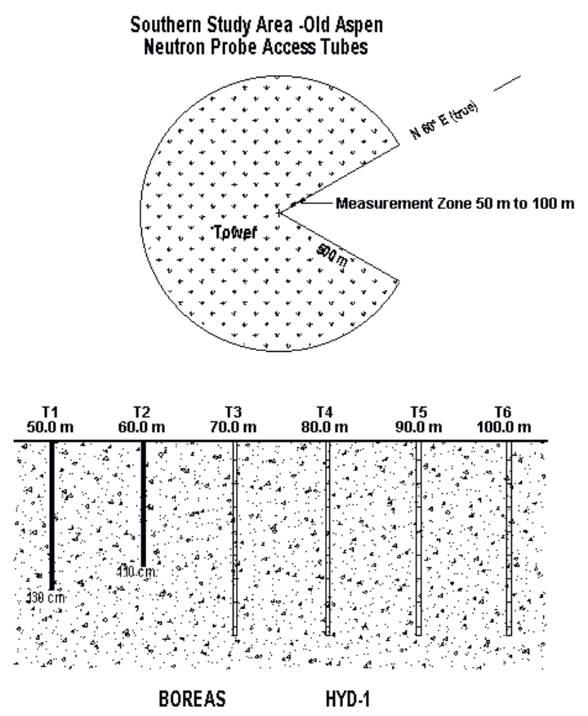

NSA-OJP: The neutron probe access tubes were located on a transect line that was N 37 E (true) from the flux tower. The distances from the flux tower were as follows: Tube 6, 96.2 meters; Tube 2, 100 meters; Tube 3, 104.8 meters; Tube 4, 109.8 meters; and Tube 5, 114.2 meters. Tube 1 was not monitored. Tubes 3, 4, 5, and 6 were monitored to a depth of 160 cm and Tube 2 was monitored to a depth of 140 cm. The vertical sampling resolution was 10 cm.

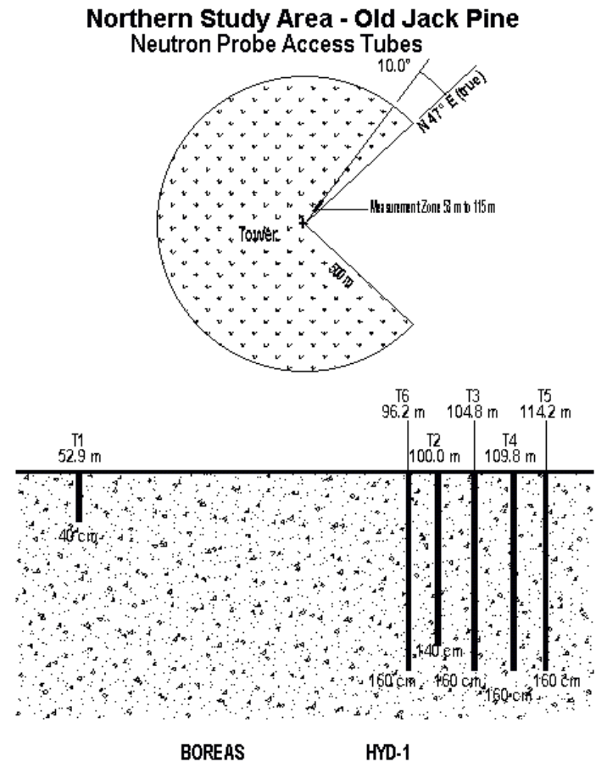

NSA-YJP: The neutron probe access tubes were located on a transect line that was N 60 E (true) from the flux tower, except for Tubes 6 and 7, which were offset 10 meters, normal to the Wind-Aligned Blob (WAB) boundary. The distances from the flux tower were as follows: Tube 2, 97.3 meters; Tube 3, 104.8; Tube 4, 110 meters; Tube 5, 120 meters; Tube 6, 120 meters; and Tube 7, 110 meters. Tubes 2 and 6 were monitored to a depth of 40 cm, Tubes 4 and 5 to a depth of 50 cm, and Tubes 3 and 7 to a depth of 60 cm. The vertical sampling resolution was 10 cm. Tube 1 was not monitored.



NSA-OBS: The MoisturePoint TDR rods were located on a transect line that was N 37 E (true) from the flux tower. The distances from the flux tower were as follows: Rod 1, 25 meters; Rod 2, 35 meters; Rod 3, 45 meters; and Rod 4, 55 meters. All rods measured to a depth of 120 cm. The vertical resolution from the "soil" surface down: 0-15 cm, 15-30 cm, 30-60 cm, 60-90 cm, and 90-120 cm.

NSA-Fen: No exact locations for the Fen TDRs exist. Three rods were installed along the flux tower boardwalk, with Rod 1 closest to the flux tower and Rods 2 and 3 being progressively farther away, but not in a straight line. See site maps for relative locations. Rods measured to a depth of 120 cm. The vertical resolution from the peat surface down: 0-15 cm, 15-30 cm, 30-60 cm, 60-90 cm and 90-120 cm.

SSA-OJP: The neutron probe access tubes were located on a transect line that was N 60 E (true) from the flux tower. Distances from the flux tower were as follows: Tube 1, 55 meters; Tube 2, 65 meters; Tube 3, 75 meters; Tube 4, 85 meters; and Tube 5, 105 meters. All tubes were monitored to a depth of 170 cm, and vertical resolution was 10 cm.
SSA-YJP: The neutron probe access tubes were located on a transect line that was N 60 E (true) from the flux tower. Distances from the flux tower were as follows: Tube 1, 50 meters; Tube 2, 70 meters; Tube 3, 75 meters; Tube 4, 80 meters; Tube 5, 85 meters; and Tube 6, 90 meters. All tubes were monitored to a depth of 100 cm and vertical resolution was 10 cm.

SSA-OBS: The MoisturePoint TDR rods were located on a transect line that was N 60 E from the flux tower. Distances from the flux tower were as follows: Rod 1, 45 meters; Rod 2, 50 meters; and Rod 3, 55 meters. All rods measured to a depth of 120 cm. The vertical resolution from the "soil" surface down: 0-15 cm, 15-30 cm, 30-60 cm, 60-90 cm, and 90-120 cm.

SSA-Fen: No exact locations for the Fen TDRs exist. Rods 1 and 2 were installed along the main fenway boardwalk, and Rod 3 was installed on the south fenway. Rods measured to a depth of 120 cm. The vertical resolution from the peat surface down: 0-15 cm, 15-30 cm, 30-60 cm, 60-90 cm, and 90-120 cm.

SSA-YA: The MoisturePoint TDR rods were located on a transect between the YA flux tower and meteorological station. Rods 1, 2, and 3 were located 4, 10, and 16 meters from the flux tower, respectively. All rods measured to a depth of 120 cm. The vertical resolution from the "soil" surface down: 0-15 cm, 15-30 cm, 30-60 cm, 60-90 cm, and 90-120 cm.

The 1995-97 measurement locations are given relative to the flux tower as follows:

SSA-OBS: In 1996, 10 manual MoisturePoint five-segment TDR rods were installed along two parallel transects of 5 rods. The first transect was located on a line N 60 E from the flux tower. The first rod was approximately 50 meters from the tower, and subsequent rods were spaced approximately 5 meters N 60 E along the transect. The second transect was located parallel to the first, with Rod 1 located approximately 5 meters to the NW of the first rod of the first transect.

NSA-OJP: In 1996, five manually read MoisturePoint probes were installed along a transect approximately 35 m, N 70 W (true), from the tower. The rods were spaced approximately 5 meters apart (see Spatial Coverage Map below). The distances from the flux tower were as follows: Rod 1, 35 m; Rod 2, 40 m; Rod 3, 45 m; Rod 4, 50 m; and Rod 5, 55 m. All rods measured to a depth of 120 cm. The vertical resolution from the "soil" surface down; 0-15 cm, 15-30 cm, 30-60 cm, 60-90 cm, and 90-120 cm.

In 1996 and 1997 an automated system using eight CS615 probes was installed. Two profiles were measured at depths of 15, 30, 60, and 90 cm. Approximate profile locations are shown in the Spatial Coverage Map below.

NSA-YJP: In 1996, five manually read MoisturePoint probes were installed along a transect beginning approximately 25 m, 250 degrees from N (true), from the tower. The rods were spaced approximately 5 meters apart (see Spatial Coverage Map below). The distances from the flux tower were as follows: Rod 1, 25 m; Rod 2, 30 m; Rod 3, 35 m; Rod 4, 40 m; and Rod 5, 45 m. All rods measured to a depth of 120 cm. The vertical resolution from the "soil" surface down: 0-15 cm, 15-30 cm, 30-60 cm, 60-90 cm, and 90-120 cm.

In 1996 and 1997 an automated system using eight CS615 probes was installed. Two profiles were measured at depths of 15, 30, 60, and 90 cm. Approximate profile locations are shown in the Spatial Coverage Map below.

NSA-OBS: The MoisturePoint TDR rods were located on a transect line that was N 47 E (true) from the flux tower. The distances from the flux tower were as follows for Rods 1 through 8: 25, 30, 35, 40, 45, 50, 55, and 60 meters. All rods measured to a depth of 120 cm. The vertical resolution from the "soil" surface down: 0-15 cm, 15-30 cm, 30-60 cm, 60-90 cm, and 90-120 cm.

SSA-OA: The MoisturePoint TDR rods were located along a transect line that was N 60 degrees E (true) from the flux tower. The distances from the flux tower were as follows for Rods 1 through 8: 50, 60, 70, 80, 90, 100, 110, and 120 meters. All rods measured to a depth of 120 cm. The vertical resolution from the "soil" surface down: 0-15 cm, 15-30 cm, 30-60 cm, 60-90 cm, and 90-120 cm.

7.1.2 Spatial Coverage Map

The investigators provided the following maps for the NSA-OJP and NSA-YJP data collection in 1995-97. It is important to note that these maps do not necessarily represent the locations of the TDR equipment in 1994.

1996 Measurements at NSA OJP



1995-1997 Measurements at NSA YJP

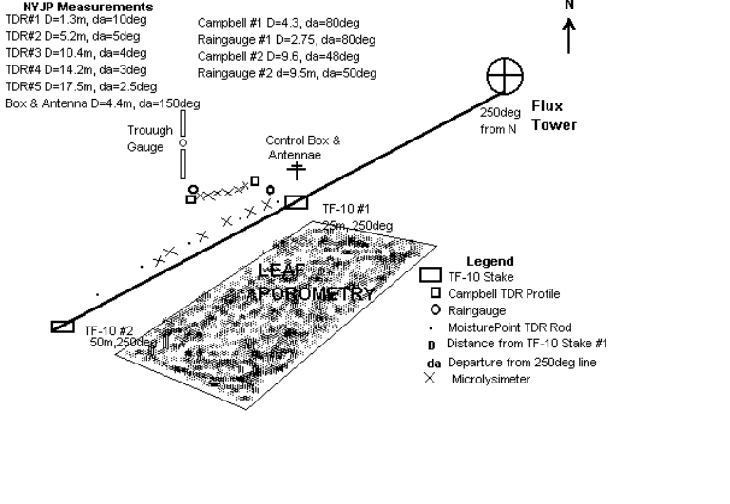

7.1.3 Spatial Resolution

These measurements were made at a set of point locations.

7.1.4 Projection

Not applicable for point data.

7.1.5 Grid Description

Not applicable.

7.2 Temporal Characteristics

7.2.1 Temporal Coverage

In 1994, soil moisture data were collected every other day within the IFCs. Some additional data are available between IFC-2 and IFC-3. In 1995-97, most data were collected by automated equipment, and measurements were recorded at various time intervals (4 hours to 15 minutes), depending on the type of instrumentation. Overall the data cover the period of 25-MAY-1994 to 26-JUN-1997.

7.2.2 Temporal Coverage Map

1994

Data Collection
Site Start End
NSA-Fen 03-Aug-1994 18-Sep-1994
NSA-OBS 04-Aug-1994 18-Sep-1994
NSA-OJP 30-May-1994 17-Sep-1994
NSA-YJP 30-May-1994 17-Sep-1994
SSA-YA 24-Jul-1994 17-Sep-1994
SSA-Fen 05-Jun-1994 17-Sep-1994
SSA-OBS 04-Jun-1994 17-Sep-1994
SSA-OJP 25-May-1994 18-Sep-1994
SSA-YJP 25-May-1994 18-Sep-1994
SSA-OA 26-May-1994 17-Sep-1994

1995 to 1997

Data Collection
Site Start End

NSA-OBS 13-Jul-1995 26-Jun-1997
NSA-OJP 25-Jun-1996 06-Nov-1996
NSA-YJP 28-Jun-1996 11-Nov-1996
SSA-OA 27-Mar-1996 06-Nov-1996
SSA-OBS 10-May-1996 06-Oct-1996

7.2.3 Temporal Resolution

In 1994, soil moisture data were collected on an every other day basis within the IFCs. Some additional data are available between IFC-2 and IFC-3.

After 1994, most data were collected by automated equipment, and measurements were recorded at various time intervals (4 hours to 15 minutes), depending on the type of instrumentation.

7.3 Data Characteristics

Data characteristics are defined in the companion data definition file (h01smpvd.def).

7.4 Sample Data Record

Sample data format shown in the companion data definition file (h01smpvd.def).

8. Data Organization

8.1 Data Granularity

All of the soil moisture data are in one file.

8.2 Data Format(s)

The data files contain ASCII numerical and character fields of varying
length separated by commas. The character fields are enclosed with single
apostrophe marks. There are no spaces between the fields. Sample data records are shown in the companion data definition file (h01smpvd.def).

9. Data Manipulations

9.1 Formulae

9.1.1 Derivation Techniques and Algorithms

For the neutron probe data, the following equation was used:

ThetaV = A ( NMR / STD ) + B

where:

ThetaV = volumetric soil moisture
A = a soil-specific coefficient
B = a soil-specific coefficient
NMR = the neutron probe count
STD = standard neutron probe count taken at the beginning and end of day

MoisturePoint Calibration

Calculation of volumetric moisture content from segment travel time data
Tmc = Tm/B - A ThetaV =(Tmc/Tair-Ts/Tair)/(Kw-1)^{0.5}
Tmc = Time Corrected Tm - Time from MP917
Ts/Tair = 1.64 for clay Kw = dielectric constant of water = 79.4
Ts/Tair = 1.55 default for MP917
Ts/Tair = 1.14 for peat
Ts/Tair = 1.39 for average of peat and clay
Tair = 2*Lseg/299.704, where Lseg = segment length in mm
Tair is round trip propagation time in air in nsec

MP917 defaults
A B
Segment 1 0.91 0.676
Segment 2 1.123 0.662 ThetaV is volumetric soil water content
Segment 3 1.475 0.651
Segment 4 1.54 0.68
Segment 5 1.742 0.669

CS615 Water Content Reflectometer Calibration

The calibration relationship is
ThetaV = 0.3538*t³-1.9567*t²+3.9122*t-2.5441
with ThetaV the volumetric water content and t the pulse period in milliseconds. Different soils and probes show an error, which appears as an offset. The calibration was optimized by taking measurements at several known water contents and the last term in the calibration (zero order coefficient) was adjusted to compensate.

9.2 Data Processing Sequence

9.2.1 Processing Steps

BORIS processed the data by:

1) Reviewing the initial data files and loading them online for access.
2) Designing relational data base tables to inventory and store the data.
3) Loading the data into the relational data base tables.
4) Working with the HYD-01 team to document the data set.
5) Extracting the standardized data into logical files.

9.2.2 Processing Changes

None.

9.3 Calculations

The neutron probe raw count data were used in a computer program (HYDROSOL, Richard H. Cuenca) in which the volumetric moisture content was calculated using the equation ThetaV = A ( NMR / STD ) + B, in which A and B are soil-specific coefficients, NMR is the neutron probe count, and STD is the standard count taken at the beginning and end of each field day. The MoisturePoint TDR gives volumetric moisture content directly. This is determined by internal calibration programmed by the manufacturer.

9.3.1 Special Corrections/Adjustments

None.

9.3.2 Calculated Variables

None.

9.4 Graphs and Plots

None.

10. Errors

10.1 Sources of Error

The change in moisture content should be accurate; however, with the neutron probe, there is the question of calibration. The absolute values of the top 10 cm of data were compared with HYD-06 (Eugene Peck) data with agreement to + or - 2%. This comparison has led to confidence in the change in moisture content values. Although there is always a chance of human error, the HYD-01 team has made every attempt to minimize these types of errors.

The primary source of error with the MoisturePoint system will be the internal calibration. Error exists at several sites where the TDR was used, including NSA-Fen, NSA-OBS, SSA-Fen, and SSA-OBS. There is error in the absolute value of the moisture content, which is caused by the use of the MoisturePoint's internal calibration that is set for soil. All of these sites had high organic matter contents whose dielectric constants are different than that of soil. However, as previously stated, the change from day to day in moisture content will be accurate. For more information on error in the equipment, contact the principal investigator.

10.2 Quality Assessment

10.2.1 Data Validation by Source

None given.

10.2.2 Confidence Level/Accuracy Judgment

None given.

10.2.3 Measurement Error for Parameters

None given.

10.2.4 Additional Quality Assessments

None given.

10.2.5 Data Verification by Data Center

The data that were received from HYD-01 were loaded into the relational data base and checked to make sure that no errors were introduced in loading the data.

11. Notes

11.1 Limitations of the Data

Equipment at the NSA-OBS site was installed in July 1995 and has been running more or less continuously year round through October 1998. During the winter months, soil moisture data will reflect frozen conditions. No attempt has been made to calibrate this soil moisture in frozen conditions. This will be seen in the data set as sudden drops in moisture content (i.e., dielectric constant decreases) during the spring and again in the fall. A relatively constant moisture content reading is seen throughout the winter.

SSA-OA site was also operated during frozen soil conditions. The same limitations apply as with the NSA-OBS site.

11.2 Known Problems with the Data

In the 1994 data, problems with the data will be noted in the quality check portion of the data table. The soil moisture data should have the same integrity throughout the data set.

No problems were explicitly identified in the 1995-97 data.

11.3 Usage Guidance

None given.

11.4 Other Relevant Information

None.

12. Application of the Data Set

These data can be used to determine how soil moisture changes with time during rain events and during dry periods. It can be used in various kinds of hydrological and ecological models.

13. Future Modifications and Plans

Automated soil moisture measurement systems were operated for NSA-OBS, NSA-YJP, NSA-OJP, and SSA-OA in 1997 and NSA-OBS in 1998. These data have been collected but not processed by the principal investigator. It is hoped to include these data later.

14. Software

14.1 Software Description

Contact Dr. Richard Cuenca for information regarding the HYDROSOL software.

14.2 Software Access

Contact Dr. Richard Cuenca for information regarding the HYDROSOL software.

15. Data Access

15.1 Contact Information

Ms. Beth Nelson
BOREAS Data Manager
NASA GSFC
Greenbelt, MD
(301) 286-4005
(301) 286-0239 (fax)
Elizabeth.Nelson@gsfc.nasa.gov

15.2 Data Center Identification

See Section 15.1.

15.3 Procedures for Obtaining Data

Users may place requests by telephone, electronic mail, or fax.

15.4 Data Center Status/Plans

The HYD-01 volumetric soil moisture data are available from the Earth Observing System Data and Information System (EOSDIS) Oak Ridge National Laboratory (ORNL) Distributed Active Archive Center (DAAC). The BOREAS contact at ORNL is:

ORNL DAAC User Services
Oak Ridge National Laboratory
(865) 241-3952
ornldaac@ornl.gov
ornl@eos.nasa.gov

16. Output Products and Availability

16.1 Tape Products

None.

16.2 Film Products

None.

16.3 Other Products

ASCII text files.

17. References

17.1 Platform/Sensor/Instrument/Data Processing Documentation

Both CPN and MoisturePoint provide manuals with their equipment. Contact the manufacturers listed in Section 4.1.7 for details.

17.2 Journal Articles and Study Reports

Cuenca, R.H., D.E. Stangel, and S.F. Kelly. 1997. Soil water balance in a boreal forest. Journal of Geophysical Research 102(D24): 29,355-29,366.

Feddes, R.A., E. Bresler, and S.P. Neuman. 1974. Field test of a modified
numerical model for water uptake by root systems. Water Res. Res., Vol. 10,
No. 6, pp. 1199-1206.

Feddes, R.A., S.P. Neuman, and E. Bresler. 1975. Finite element analysis
of two-dimensional flow in soils considering water uptake by roots. II.
Field applications. Soil Sci. Soc. Am., Proc., 39:231-237.

Feddes, R.A., P.J. Kowalik, and H. Zaradny. 1978. Simulation of field water use and crop yield. PUDOC, Wageningen, 189 pp.

Sellers, P. and F. Hall. 1994. Boreal Ecosystem-Atmosphere Study: Experiment Plan. Version 1994-3.0, NASA BOREAS Report (EXPLAN 94).

Sellers, P. and F. Hall. 1996. Boreal Ecosystem-Atmosphere Study: Experiment Plan. Version 1996-2.0, NASA BOREAS Report (EXPLAN 96).

Sellers, P., F. Hall, and K.F. Huemmrich. 1996. Boreal Ecosystem-Atmosphere Study: 1994 Operations. NASA BOREAS Report (OPS DOC 94).

Sellers, P., F. Hall, and K.F. Huemmrich. 1997. Boreal Ecosystem-Atmosphere Study: 1996 Operations. NASA BOREAS Report (OPS DOC 96).

Sellers, P., F. Hall, H. Margolis, B. Kelly, D. Baldocchi, G. den Hartog, J. Cihlar, M.G. Ryan, B. Goodison, P. Crill, K.J. Ranson, D. Lettenmaier, and D.E. Wickland. 1995. The boreal ecosystem-atmosphere study (BOREAS): an overview and early results from the 1994 field year. Bulletin of the American Meteorological Society. 76(9):1549-1577.

Sellers, P.J., F.G. Hall, R.D. Kelly, A. Black, D. Baldocchi, J. Berry, M. Ryan, K.J. Ranson, P.M. Crill, D.P. Lettenmaier, H. Margolis, J. Cihlar, J. Newcomer, D. Fitzjarrald, P.G. Jarvis, S.T. Gower, D. Halliwell, D. Williams, B. Goodison, D.E. Wickland, and F.E. Guertin. 1997. BOREAS in 1997: Experiment Overview, Scientific Results and Future Directions. Journal of Geophysical Research, 102 (D24): 28,731-28,770.

17.3 Archive/DBMS Usage Documentation

None.

18. Glossary of Terms

None.

19. List of Acronyms

ASCII - American Standard Code for Information Interchange
BOREAS - BOReal Ecosystem-Atmosphere Study
BORIS - BOREAS Information System
CD-ROM - Compact Disk - Read Only Memory
DAAC - Distributed Active Archive Center
EOS - Earth Observing System
EOSDIS - EOS Data and Information System
ET - evapotranspiration
GSFC - Goddard Space Flight Center
HTML - Hypertext Markup Language
HYD - Hydrology
IFC - Intensive Field Campaign
MP - MoisturePoint
NASA - National Aeronautics and Space Administration
NP - Neutron Probe
NSA - Northern Study Area
OA - Old Aspen
OBS - Old Black Spruce
OJP - Old Jack Pine
ORNL - Oak Ridge National Laboratory
PANP - Prince Albert National Park
SSA - Southern Study Area
TDR - Time Domain Reflectometry
TE - Terrestrial Ecology
TF - Tower Flux
URL - Uniform Resource Locator
USDA - United States Department of Agriculture
VDC - Volts of Direct Current
WAB - Wind-Aligned Blob
YA - Young Aspen
YJP - Young Jack Pine

20. Document Information

20.1 Document Revision Date

Written: 01-Dec-1994
Last Updated: 02-Dec-1998

20.2 Document Review Dates

BORIS Review: 27-Nov-1998
Science Review: 30-Nov-1998

20.3 Document ID

20.4 Citation

Please contact Dr. Richard Cuenca before publishing results based on this data set.

20.5 Document Curator

20.6 Document URL

KEYWORDS
VOLUMATRIC SOIL MOISTURE

